
KULLIYYAH OF INFORMATION & COMMUNICATION TECHNOLOGY
SEMESTER 2, 2023/2024
CSCI 1305 INTRODUCTION TO SOFTWARE ENGINEERING
SECTION <1/2/3>

EXERCISE : BOOK FLIGHT
USE CASE SPECIFICATION

PREPARED BY: GROUP <ID>

NAME | MATRIC NO. | PARTICIPATION
<Leader’s Name>  (NOTE: GROUP LEADER PLEASE MONITOR EACH MEMBER’S PARTICIPATION) | <matricno> | <100%>
<Name> | <matricno> | <100%>
<Name> | <matricno> | <100%>
<Name> | <matricno> | <100%>
<Name> | <matricno> | <100%>

LECTURER
DR. SITI ASMA MOHAMMED

DUE
<Check due>

Use Case SpecificaTIon
<Instruction:
- Remove this instruction part when your task is completed.
- Make sure the review column on the right is closed BEFORE you convert this file to PDF.
- This template is used for one use case specification only.
- For this exercise, you only need to prepare for one use case specification.
- Remove all these tags when you finish with this template. Please double check your submission, do not include tags and red fonts. >

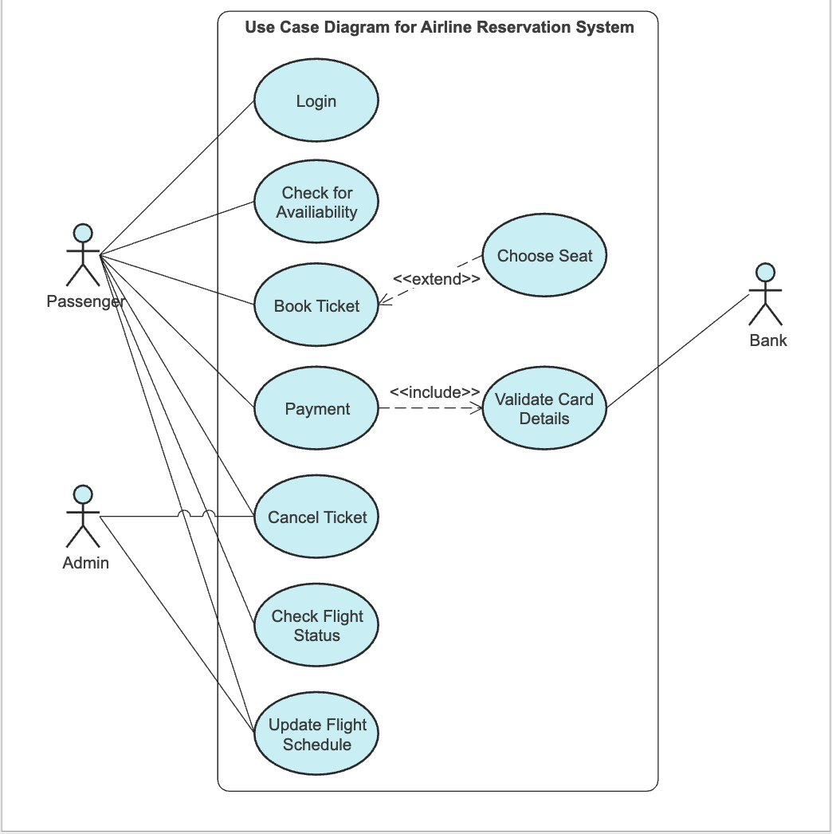
Figure 1: Use case Diagram for Flight Reservation System (Don’t forget to put caption)

Use Case Specification for Book Ticket
Use Case ID: | FRS-BF-1.0
Use Case Name: | Book Ticket <must be exactly the same name as in the use case diagram> | Version No: | <1.0>
Objective: | < The directly observable purpose of this use case >
Created by: | <Name> | On (date): | <Date>
Last Update by: | <Date> | On (date): | <Date>
Approved by: | <Name> | On (date): | <Date>
User/Actor: | <Description of the person who uses the system to accomplish tasks>
Business Owner Name: | <Name> | Contact Details: | <Tel no/email>
Trigger: | User
Frequency of Use: | <How often does this series of activities occurs? Frequent, Any time, On demand>

Pre-conditions
The user must have (to be completed)

Basic Flow
Step | User Actions | System Actions
1 | The use case starts when the user intends to book a flight ticket. | The system displays the flight reservation system.
2 |  | The system prompts the user to enter <what information required?>.
3 | The user enters his <what information?>. | The system searches the flight details. [E1: No available flight]
4. |  | The system ….
5. | The user chooses …. | The system prompts …
6. | The user enters … | The system checks ….
7. | <Add steps here>
 | <Add steps here>
 | The use case ends when <to be completed>.

Alternate Flow: A1: <Other options>
Step | User Actions | System Actions
1 |  | The system displays …
2 | The user selects the …. option. | …..
3 | The use case ends <or does the flow go back to the main flow?>.

Alternate Flow: <A2: Edit this>
Step | User Actions | System Actions
1 | <Edit this part>
2
3

Exception Flow: E1: No available flight
1 |  | The system displays “Error, no available flight”.
2 |  | The system ….
3 | Continue to Step x in the basic flow.

Exception Flow: E2: <what error>
1 |  | The system displays “Error”.
2 |  | The system <to be completed>.
3 | The use case ends.

Post conditions
- The user gets his <to be completed>.

<Note: The following contents are optional, only use it if required.>

Includes or Extension Points
- <Common functionality that appears in multiple use cases can be split out into separate use cases. Provide reference to such of the use cases that are called by the subject use case. >

Special Requirements
- <Identify any special non-functional requirements such as legal, performance, etc. that need to be considered during design or implementation. These requirements should only be documented here if they are specific to this use case. If the requirements span across multiple use cases, document in the appropriate section of the Systems Requirements Specification>

Business Rules
- <add any business rules that are relevant to this use case specification>

Other Notes (Assumptions, Issues,)
< Any special considerations that need to be kept in mind for this use case only; identify the type of item with a tag like
Assumptions:
Issues:>

